**Participant ID ___________**

**Instructions for Participants**

1. Take the test **each morning when you wake up**. You should not have urinated 4 hours before you take your test. Try to take your test around the same time each day.
2. Use the test instructions (below) to take your test.
3. If you get :
   1. A **negative result**, try again the next day.
   2. A **positive result**,
      1. **Email** the lab saying “Hi, my name is ______. My participant ID is _______. I got a positive result on _________ (today’s date).
4. Keep taking the tests until you get a positive result.
   * 1. If you **never get a positive result**, **email** the lab when you run out of tests, saying “Hi, my name is ____________. My participant ID is ___________. I took all of my tests and never got a positive result.
5. Please **bring back** to the lab :
   1. **Unused test sticks**

**You will begin taking your tests on: ______________________**

**You will take your last test on: _________________________**

*If you never get a positive result, you will email the lab on this day.

Contacting the Lab:

Email: [chenlabstudy@gmail.com](mailto:chenlabstudy@gmail.com)

How to Use the Hormone Test Sticks:

1. Urinate into a small cup

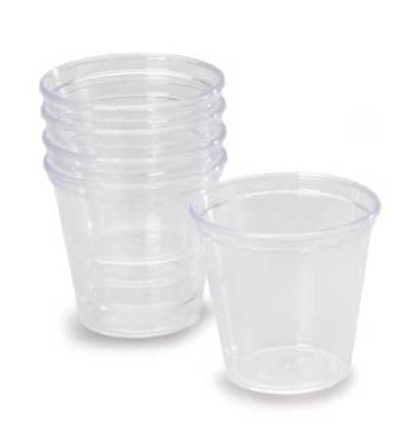

2. Remove the Test Stick from the sealed pouch

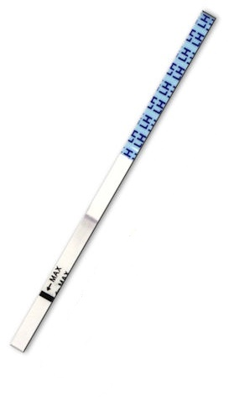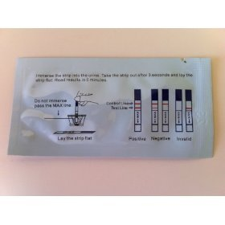

**Insert this end**

**Handle**

3. Hold the test strip by the blue handle and immerse the strip into the urine up to the line labeled “MAX.” Do not allow urine level to exceed MAX. The arrow should be pointing towards the urine.

4. Take the strip out after 3 seconds and lay the strip flat on a clean, dry, non-absorbant surface, such as the top of your toilet.

5. Wait 5 minutes

6. Read the test. There are two possible lines. The top one (closer to the handle) is the control line (should always be there). The bottom line is the test line. If the test line is as dark as the control line, you are ovulating. Please email us!

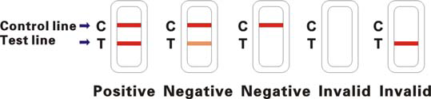

7. Below is another chart showing how to read the results

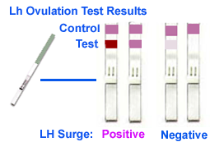

8. If your results are invalid, please email us immediately. Otherwise, email us once you get a positive result.